5 Prince Publishing Presents
Throne of Jelzicar
S.D. Galloway
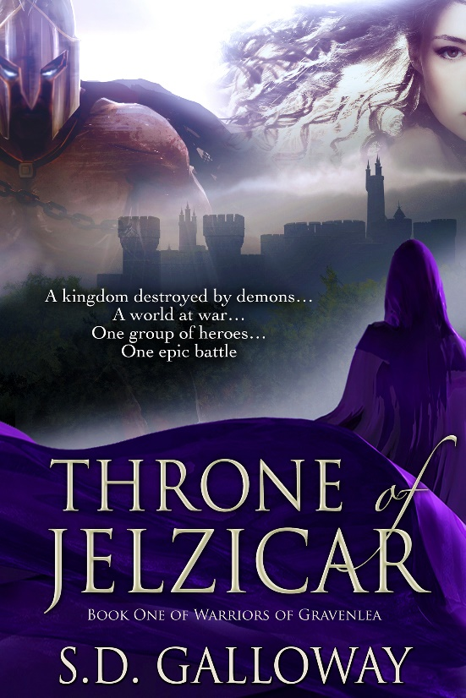
Years ago, a young warlock released Emph, the Lord of Demons, from the depths of hell. Emph laid waste to the land as he consumed kingdoms, including Jelzicar. Now, as his own village is threatened, Drahvyn has been contacted by a Priestess to fulfill a prophecy. Together with his dagger wielding sister, an elven archer, a dwarven warrior, and a creature made of both good and evil, they will travel with a mysterious woman, believed to be the key to Emph’s undoing, to battle the demon lord once and for all. There will be many obstacles. Survival is not promised to them. The fate of their world will depend upon the courage of these few.

ISBN/SKU: 1631121383
ISBN Complete: 978-1-63112-138-8
Title: Throne of Jelzicar
Publication Date: 12 /3/ 2015
Book Type: B&W 5.25 x 8 in or 203 x 133mm Perfect Bound on Creme w / Gloss Lam
Page Count: 201

Contributors
Galloway, S.D.

Subject Code Description
FIC009000 FICTION / Fantasy / General

Author S. D. Galloway is a resident of Phoenix, AZ. A lover of fantasy, a gamer, and a self-proclaimed nerd, the world of warriors and magic users is a place she visits frequently in her mind. She is also a Family Nurse Practitioner with a passion for working with military members and their families. Currently she is in Monterey, CA where her husband is stationed with the US Army. They have four children, two Great Danes, and a cat. She adores readers of all genres of books and writers of all styles. Believing that books are a sacred commodity, she keeps one with her at all times so that a book is always available should the opportunity to read arise. Now she invites you to journey with her to Jelzicar and other far-away lands as the Warriors of Gravenlea take on the demon empire that threatens their world. Gather your weapons, put on your armor, and prepare to walk with her through the world of fantasy that she has created just for you.

http://www.5princebooks.com/sdgalloway.html

Available through INGRAM

Market
1: Australia
14.95 AUD List Price
55.00 % Wholesale Yes-Returnable

2: European Union
9.95 EUR List Price

3: United Kingdom 9.95GBP List Price
55.00 % Wholesale Yes-Returnable

4: United States
10.95 USD List Price
55.00 % Wholesale
5 PRINCE PUBLISHING

Denver, Colorado
http://www.5princebooks.combooks@5princebooks.com

